Fy hoff raglenni
- Llenwa dy gynlluniwr Sky+ gyda dy hoff raglenni.
Fill in your Sky+ planner with your favourite programmes.
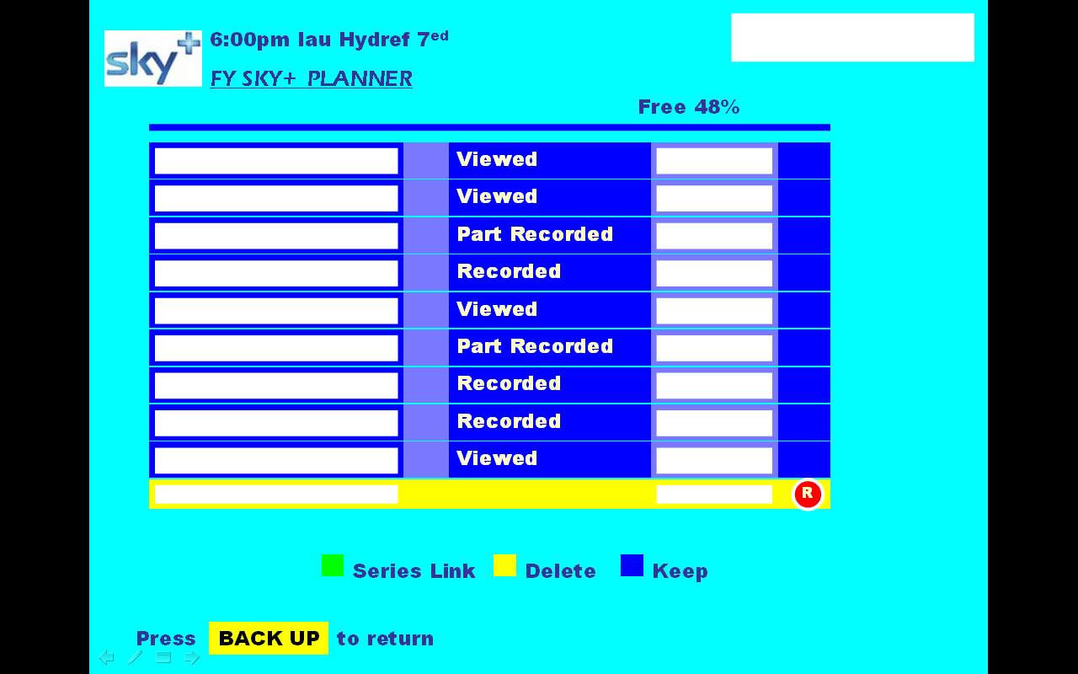

- Rwyt ti wedi recordio dy Sky+ delfrydol di. Nawr, ysgrifenna pam dewisiaist ti’r rhaglenni.
You have recorded your own Sky+. Now, write about why you chose these, giving as much information as possible.

……………………………………………………………………………………………………………………………………………………………………………………………………………………………………………………………………………………………………
…………………………………………………………………………………………………………………………………………………………………………………………………………………………………………………………………………………………………………………………………………………………………………………………………………………………………………………………………………………………………………………………………………………………………………………………………………………………………………………………………………………………………………………………………………………………………………………………………………………………………………………………………………………………………………………………………………………………………………………………………………………………………………………………………………………………………………………………………………………………………………………………………………………………………………………………………………………………………………………………………………………………………………………………………………………………………………………………………………………………………………………………………………………………………………………………………………………………………………………………………………………………………………………………………………………………………………………………………………………………………………………………………………………………………………………………………………………………………………………………………………………………………………………………………………………………………………………………………………………………………………………………………………………………………………………………………………………………………………………………………………………………………………………………………………………………………………………………………………………………………………………………………………………………………………………………………………………………………………………………………………………………………………………………………………………………………………………………………………………………………………………………………………………………………………………………………………………………………………………………………………………………………………………………………………………………………………………………………………………………………………………………………………………………………………………………………………
……………………………………………………………………………………………………………………………………………………………………………………………………………………
……………………………………………………………………………………………………………………………………………………………………………………………………………………
……………………………………………………………………………………………………………………………………………………………………………………………………………………
……………………………………………………………………………………………………………………………………………………………………………………………………………………
……………………………………………………………………………………………………………………………………………………………………………………………………………………
……………………………………………………………………………………………………………………………………………………………………………………………………………………
……………………………………………………………………………………………………………………………………………………………………………………………………………………
……………………………………………………………………………………………………………………………………………………………………………………………………………………
……………………………………………………………………………………………………………………………………………………………………………………………………………………

Vanessa Brown 2007

